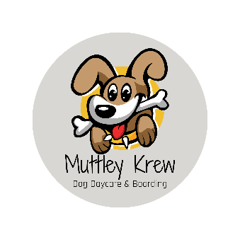

Social Media Release

We love to take photos of your dog during their stay with us and share them on our social media channels. We'd like to share your dog's experience with us and communicate this on social media with your permission. By signing this release form you are giving us permission to share your dog's photos and experience at Muttley Krew LLC on social media and for use in our marketing and future promotions. We completely understand and respect your decision if you would prefer us not to use photos of your dog online.

Please select one:

I _____________ hereby grant Muttley Krew LLC permission to use photographs/videos of my dog during their stay with Muttley Krew LLC, in publications, newsletters, social media, and online.

I _____________ do NOT grant permission for my dog's photos to be used online, on social media, or in any marketing materials.

Dog’s Name: ______________________________
Owner Signature: ___________________________
Date: _______________

