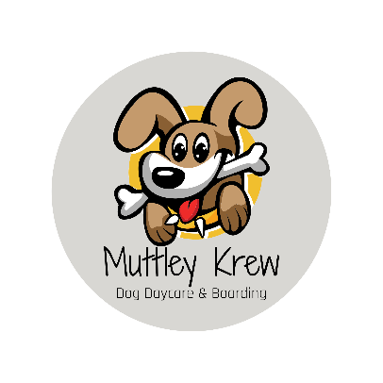

MEDICAL RELEASE FORM
This is a required form for all Muttley Krew LLC clients receiving services.

First and foremost, the safety and well-being of your dog(s) is of the highest importance. Ensuring your dog remains safe and well cared for is our first responsibility and as such we take it very seriously. We do our best to have our pet parents screen for preexisting health conditions, but some factors may be beyond our control. In the event a medical emergency arises while your dog is in our facility or participating in a service, we provide it is imperative we are immediately able to get them medical treatment at the closest available clinic. We will call ahead to the veterinary offices closest in proximity to us to ensure they can handle the emergency care required. Your dog will be immediately taken to the closest available clinic for treatment, and you will be notified immediately. Please note, will notify you immediately after we have secured a medical treatment facility for your dog, to avoid any delays in treatment. Our goal is to get your dog medical attention as quickly as possible. For this reason, it is a requirement to have our dog owners sign this medical release form.

I understand in the event of a medical emergency that if Muttley Krew LLC, at its sole discretion, deems the need for immediate emergency medical attention of a licensed veterinarian for my dog, I authorize Muttley Krew LLC to seek emergency medical attention for my dog at the nearest veterinary clinic available. I further agree that I am financially responsible for any medical treatment my dog receives as a result of emergency medical services provided.

Signature of Owner: ____________________________
Printed Name: ________________________________
Date: _______________

Dog’s Name: ___________________
Age: ________________________
Breed: _______________________
Current Medications/Allergies: _____________________________________
Pertinent Medical History: ________________________________________

