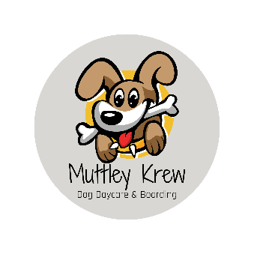

Daycare & Boarding Policies

Hours:
- Currently we do not have scheduled opening and closing times. All dogs must have appointments and times will be determined at the time appointment is made. Walk-ins are not accepted at this time.

General Policies:
- All dogs must be on a leash while on the premises, for everyone’s safety.
- Payment is due at the time of drop-off unless other arrangements have been made prior to drop-off. We accept cash, checks or Venmo.
- Please make sure all doors and gates you enter and exit through are properly secured behind you.
- Please stick to scheduled drop-off and pick-up times. Dogs will be separated during those times to avoid overstimulation. If you need to change your drop-off or pick-up times, please text or call ahead.
- If your pet is not feeling well or showing any signs of illness such as coughing stomach upset, vomiting, etc., please do not bring them in. Please let us know as soon as possible if they will not be attending. Please also make us aware of the symptoms your dog is having so we can monitor all other dogs closely.
- Your dog must be current on all required vaccinations, and flea & tick prevention and must be negative for worms. (Please go to www.muttleykrew.com for a full list of requirements)
- All dogs must be spayed or neutered if over 9 months old.
- Boarding is currently only offered to our established daycare dogs.
- PLEASE do not get offended if we determine Muttley Krew is not the best fit for your dog. Safety and contentment are our number one priority. If your dog is stressed/worried, or shows any signs of aggressive behavior, we might suggest you try an in-home pet sitter or working with a trainer to see if the concerns can be resolved.

Cancellations:
- Please be courteous and give as much notice as possible when canceling. Because we only have 4-5 dogs in our care at a time, it impacts us greatly when we have no-shows.

Always feel free to call, text, or message me with any questions or concerns. ~ Bobbie

